Syndicate Agreement
Prudentia Syndicate Agreement
Evolution Stables – Prudentia (NZ)
NZTR Authorised Syndicator
Date: 22 Feb 2026

1. Formation
A Syndicate is formed under the New Zealand Thoroughbred Racing Inc. ("NZTR") Bloodstock Syndication Code of Practice ("COP"), in accordance with Clause 3.1, by the Promoter as set out in the attached Product Disclosure Statement ("the Syndicate").
2. Object
The object of the Syndicate is to lease and race Prudentia (NZ) as a recreational pursuit, with all syndicate members holding digital, tokenised leasehold shares for a fixed 18-month term, as described in the Product Disclosure Statement.
3. Agreement and Parties
This Agreement is binding on the Promoter (Evolution Stables), the Syndicate Manager (Evolution Stables), and each Shareholder (token holder) as defined in the Product Disclosure Statement. By signing the Application Form (physically or digitally via Tokinvest), each Shareholder agrees to be bound by this Agreement and the Product Disclosure Statement. This Agreement may only be altered by special resolution (75% of shareholding) and must not increase a Shareholder’s liability beyond what is disclosed in the Product Disclosure Statement.
4. Syndicate Shares (Tokens)
The Syndicate is divided into 20 digital shares (tokens) of 0.25% each, representing a 5% leasehold interest in Prudentia (NZ) for the Lease Term. Shares are issued and recorded on Tokinvest’s VARA-compliant platform, enabling digital onboarding, compliance, and (subject to Manager approval) transfer. Each Shareholder’s rights and obligations are proportional to their shareholding.
5. Lease Duration
The lease term is fixed at 18 months, commencing 1 January 2026 and ending 30 June 2027. All lease terms are counted in full calendar months, with a minimum duration of 18 months hardwired into the product structure. The lease may be renewed or extended at the Manager’s and Lessor’s discretion, with terms disclosed to Shareholders prior to renewal.
6. Manager’s Powers and Duties
The Manager (Evolution Stables) is responsible for overall lease administration and NZTR compliance, including communication with shareholders and coordination with licensed professionals.
The Manager may:
- Make all day-to-day decisions relating to racing, training, spelling, and horse welfare.
- Appoint or change trainers in consultation with the horse’s owner or Racing Manager.
- Deduct and retain management, platform, and administration fees as disclosed in the Product Disclosure Statement.
- Delegate operational duties to licensed parties (e.g., trainers, racing managers) as required.
- Provide monthly reports and weekly updates when the horse is in training or racing.
7. Financial Contributions and Fees
All costs are covered by the one-time, upfront lease fee as detailed in the Product Disclosure Statement. No further payments are required during the Lease Term unless the lease is renewed. Tokinvest platform fees and management fees are included in the upfront payment.
8. Revenue Streams and Distribution
Token holders are entitled to a share of all revenue generated by Prudentia during the lease period, proportional to their leased stake. For Prudentia, the revenue split is 75% to token holders (the Syndicate), 25% retained by the Lessor (owner).
Potential Revenue Streams include:
- Race winnings (prizemoney, bonuses)
- Sponsorship & endorsements
- Media & naming rights
- Digital asset income (e.g., NFTs, royalties)
- Appearance fees
- Merchandising & hospitality
- Data licensing
- Breeding or exit proceeds (if applicable, subject to standard buyout clause: 3x the remaining lease value)
- Other reasonable and verifiable income directly attributable to the horse during the lease period
Insurance proceeds are not payable to lease holders. Distributions are made via Tokinvest’s platform or by direct bank transfer, within 30 days of receipt from NZTR or other sources.
9. Insurance and Early Termination
The horse will be insured for mortality and specified risks at the owner’s discretion for the duration of the lease. Insurance proceeds, if any, are payable to the owner/lessor and not to the syndicate or lease holders. If the horse dies or is retired due to injury or illness during the lease term, this agreement and the lease will terminate immediately. Lease holders will receive a pro-rata refund of the lease fee for the unused portion of the lease term, calculated from the date of termination to the scheduled end of the lease. No further compensation or insurance proceeds are payable to lease holders.
10. Transfer of Shares (Tokens)
Shares (tokens) may only be transferred with the written consent of the Manager and in accordance with NZTR and Tokinvest rules. Transfers must be processed via the Tokinvest platform, subject to AML/CFT and eligibility checks. There is no guarantee of liquidity or a secondary market for shares.
11. Decision-Making and Voting
This is a fully managed syndicate. Token holders do not carry governance or voting rights. All decisions relating to the horse, lease terms, or commercial activities are made by the Manager (Evolution Stables) in accordance with this Agreement and the Product Disclosure Statement.
Evolution Stables may, at its discretion, invite token holder input for engagement purposes (e.g., naming polls or merchandise ideas). This input is welcomed but non-binding and does not confer decision-making authority.
12. Dispute Resolution
Disputes must first be raised with the Manager in writing. If unresolved, disputes may be escalated to NZTR (syndication@nzracing.co.nz) and, if necessary, to independent mediation as per NZTR guidelines.
13. Removal of Manager
Shareholders may remove the Manager by special resolution (75% majority) in accordance with NZTR Code of Practice Clause 18.4.
14. Winding Up and Post-Lease Arrangements
At the end of the Lease Term, the Syndicate will be automatically wound up. The lease does not roll over unless the Manager (Evolution Stables) offers a renewal and participants opt in under new terms. If the horse is retired, injured, or otherwise unable to race during the lease period, the lease will be terminated early. In such cases, lease holders will receive a pro-rata refund of their original lease fee based on the number of full months remaining. Evolution Stables holds itself and its partners to the highest standards of care, ensuring that animal welfare remains central to all decisions made during the lease. All post-racing arrangements are the responsibility of the horse’s connections and are expected to comply with NZTR’s welfare guidelines.
15. Governing Law
This Agreement is governed by the laws of New Zealand.
16. Notices
Notices may be sent by email or via Tokinvest’s platform to the addresses provided by Shareholders.
17. Execution
By executing the Application Form (whether physically or electronically via Evolution Stables or Tokinvest), each Shareholder is deemed to have accepted and agreed to be bound by this Agreement and the accompanying Product Disclosure Statement.

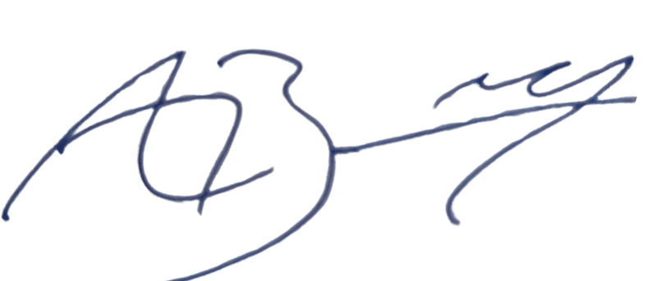

Alex Baddeley
Director, Evolution Stables Ltd

